1. Go to local wildfly server and find standalone folder

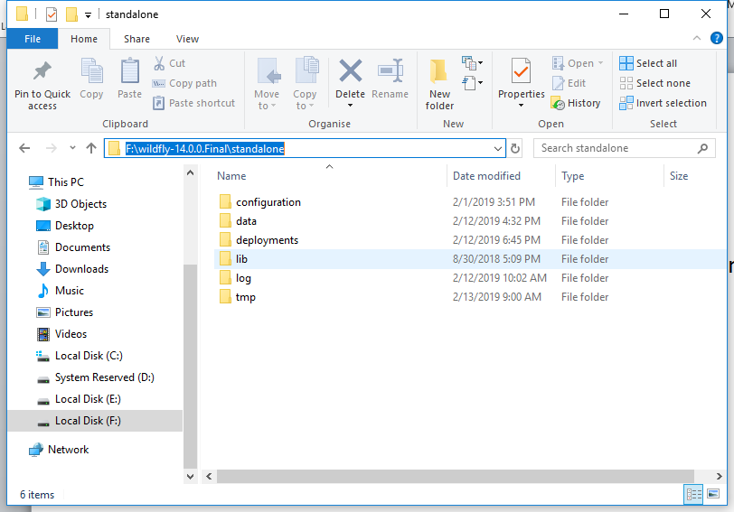

1. Go to data folder， create a folder called images

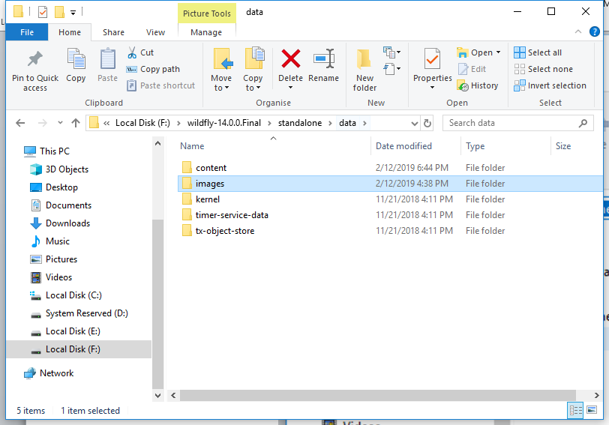

1. Go to /standalone/configuration folder, edit the standalone.xml file

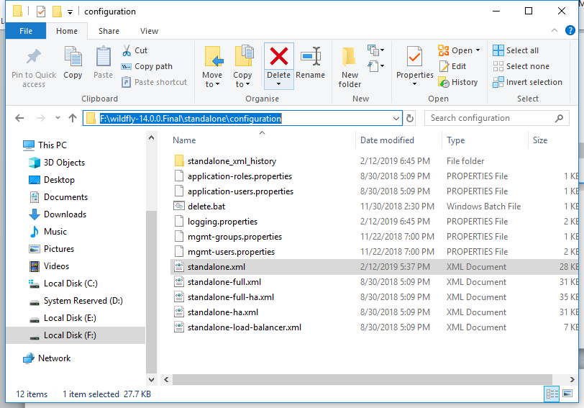

1. Add below configurations:

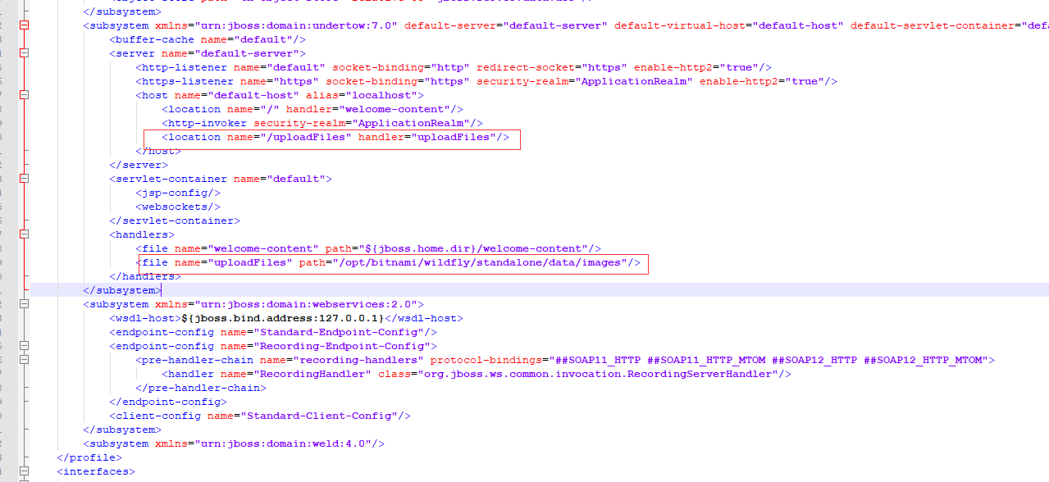

Contents are (yellow highlights are to be added):

<subsystem xmlns="urn:jboss:domain:undertow:7.0" default-server="default-server" default-virtual-host="default-host" default-servlet-container="default" default-security-domain="other">

<buffer-cache name="default"/>

<server name="default-server">

<http-listener name="default" socket-binding="http" redirect-socket="https" enable-http2="true"/>

<https-listener name="https" socket-binding="https" security-realm="ApplicationRealm" enable-http2="true"/>

<host name="default-host" alias="localhost">

<location name="/" handler="welcome-content"/>

<http-invoker security-realm="ApplicationRealm"/>

<location name="/uploadFiles" handler="uploadFiles"/>

</host>

</server>

<servlet-container name="default">

<jsp-config/>

<websockets/>

</servlet-container>

<handlers>

<file name="welcome-content" path="${jboss.home.dir}/welcome-content"/>

<file name="uploadFiles" path="<your local images path>"/>

</handlers>

</subsystem>